Contact
Sarah Arnold
Marketing Communications
Herbold Meckesheim GmbH
Industriestraße 33
74909 Meckesheim/Deutschland

Telefon +49 (0)6226 932-0
sarah.arnold@herbold.com
www.coperion.com

Press Release

Herbold Meckesheim Delivers Second PET Washing Line to Doğa PET, Expanding Recycling Capacity in Türkiye

Meckesheim, Germany, March 2026 – Herbold Meckesheim, a specialist in machinery and system solutions for plastics recycling, has been commissioned by Turkish recycling company Doğa PET to deliver a second PET bottle washing line. The order follows the successful operation of the first washing line, which has been in continuous operation since the first quarter of 2024. With the new installation, Doğa PET will double its existing washing capacity at its recycling site in Kırklareli, Türkiye to produce a daily output of 200 metric tons of rPET flakes. The project underlines the confidence placed in Herbold Meckesheim as a system supplier and long-term technology partner for complex recycling applications.

Proven Performance Drives Expansion Decision

The first washing line supplied by Herbold Meckesheim has been producing high-quality rPET flakes for two years. According to the customer, stable operation and consistent output quality were the decisive factors behind the decision to invest in a second, technically identical system. The new line is designed with the same core process layout and throughput parameters as the existing line, ensuring reliable scalability and operational consistency and features key technologies such as forced feeding granulators, hot wash system in batch design, and hydrocyclone density separation. However, while the overall configuration of the new washing line corresponds with the proven design of the first plant, selected process modules have been optimized based on operational experience and variations in input material composition. A further improvement is the increase in pre-sorting capacity to 8.0 t/h. To achieve this, Herbold is supplying a debaler and a washing drum that integrates both wet and dry sections into a single machine. These adjustments aim to further stabilize throughput and efficiency.

Preparations for the delivery of the second washing line are currently underway. The first shipments are scheduled for early March 2026. Installation and commissioning at the customer’s site are expected to start shortly thereafter. Herbold Meckesheim will support the project through all phases, from logistics coordination and on-site installation to system start-up and operator training.
“The first washing line has been running reliably since its commissioning and consistently delivers the product quality we require,” said Ömer Ayvacı, Chairman of the Board of the Doğa Group. “Based on this positive experience, it was a logical step for us to expand capacity with a second line from Herbold Meckesheim.”
“Repeat orders like this confirm that our customers value not only our technology, but also our role as a dependable project partner,” said Stefan Lachenmayer, Global Commercial Director Recycling and Managing Director Herbold Meckesheim. “The second washing line for Doğa PET demonstrates how scalable system concepts can support long-term growth in plastics recycling.”

Meet Herbold Meckesheim and Coperion at RePlast Eurasia 2026
Trade fair attendees will have the opportunity to familiarize themselves with Herbold Meckesheim’s machine and system solutions for mechanical plastics processing, together with Coperion’s extrusion and compounding technologies, jointly delivering high-efficiency recycling systems from a single source.
From March 26–28, 2026, at the Herbold and Coperion booth in Hall 11, Booth 1101B in Istanbul, Türkiye, visitors can discover advanced technologies enhancing efficiency and automation in plastics recycling and learn how integrated solutions simplify complex recycling processes.

About Herbold Meckesheim

Herbold Meckesheim, a brand of Coperion, (www.herbold.com) is a leading recycling specialist and produces machines and plants for processing pure plastic waste from the industry as well as used, mixed and contaminated plastics. The modular system solutions for automated recycling lines are tested in the company's own technical center. More than 230 employees at the headquarters and the staff of the international agencies accompany custom-made plants and machines from the conception stage through commissioning to the end of their commercial use. Since 2022 Herbold Meckesheim is part of the Coperion's Recycling Business Unit, which offers complete solutions for plastics recycling processing. Coperion is the global industry and technology leader in compounding and extrusion systems, feeding and weighing systems, bulk material handling and services. Coperion is an Operating Company of Hillenbrand, an industrial company operating in over 40 countries serving a wide variety of industries across the world. www.hillenbrand.com



Dear Colleagues,
You can find and download this press release in German, English and Turkish as well as print-ready color images at
https://www.coperion.com/en/news-media/newsroom/
.

Editorial contact and copies:
Dr. Jörg Wolters, KONSENS Public Relations GmbH & Co. KG,
Hans-Böckler-Str. 20, D - 63811 Stockstadt am Main, GERMANY
Tel.: +49 (0)60 27/ 99 00 5-0
E-Mail: mail@konsens.de, Internet: www.konsens.de

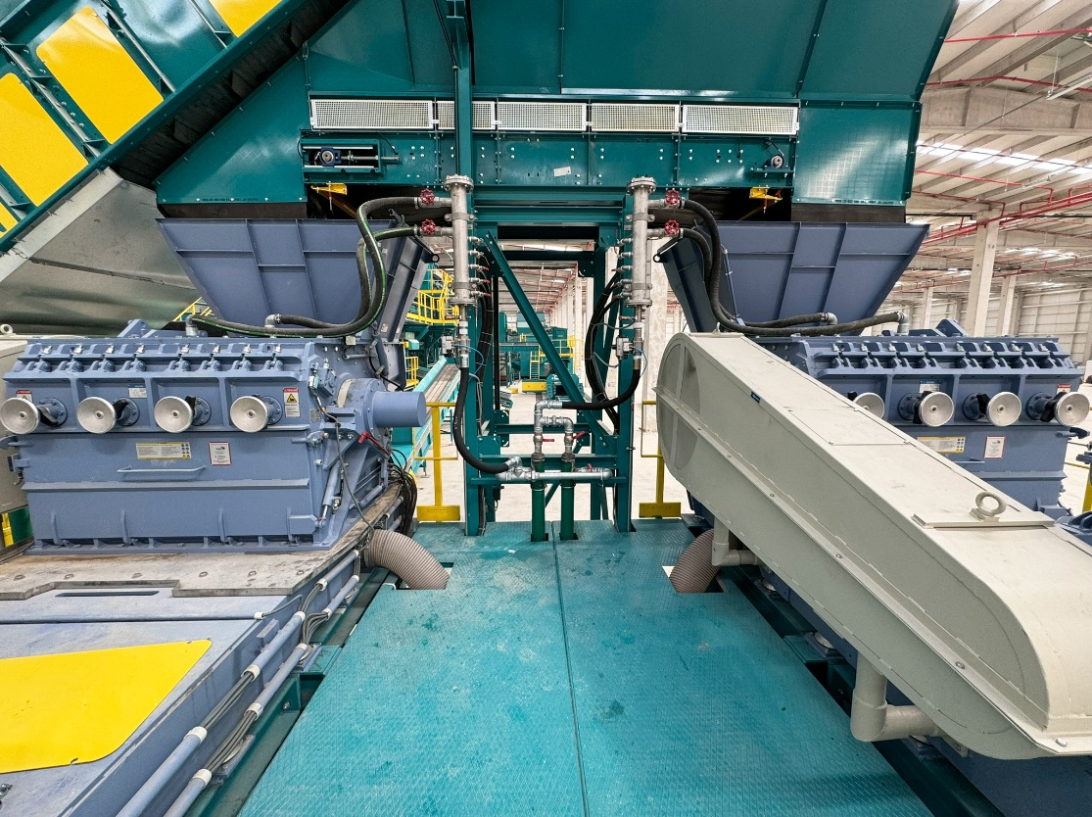
The two SMS forced feeding granulators installed in the first line ensure uniform flake size and stable material intake, creating ideal conditions for downstream washing and density separation processes.
Photo: Herbold Meckesheim, Germany

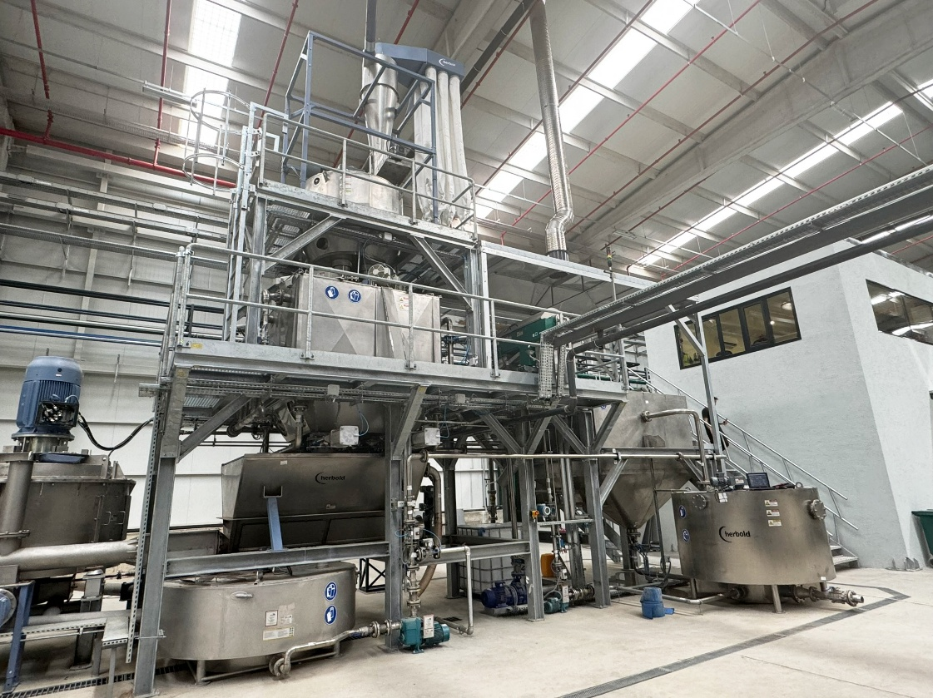
As a central process stage within the PET washing line, the hot wash system in batch design enables controlled temperature management and defined dwell times for efficient removal of labels, adhesives and organic residues.
Photo: Herbold Meckesheim, Germany

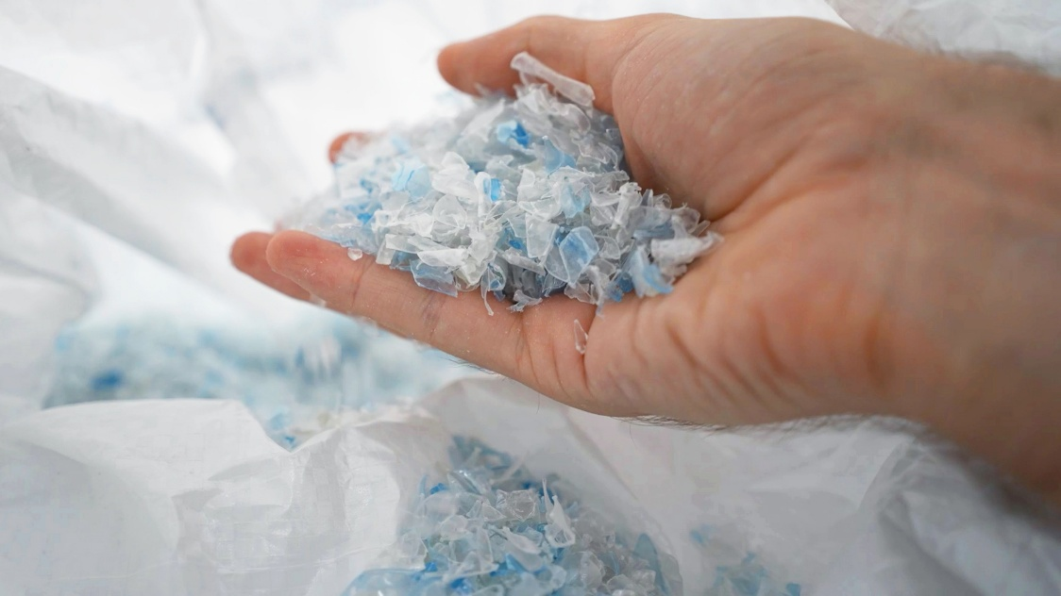
The clean rPET flakes produced on the Herbold washing line stand for consistent quality and high purity, delivering rPET ready for high-value applications.
Photo: Herbold Meckesheim, Germany

